Test Case: tc006_SPX_Dev5_Crear_Requisicion_Spot_Tipo_Cobro_Proyect_Urgent
Step 1 - Enter username and password and click to button Enter: Credentials Entered
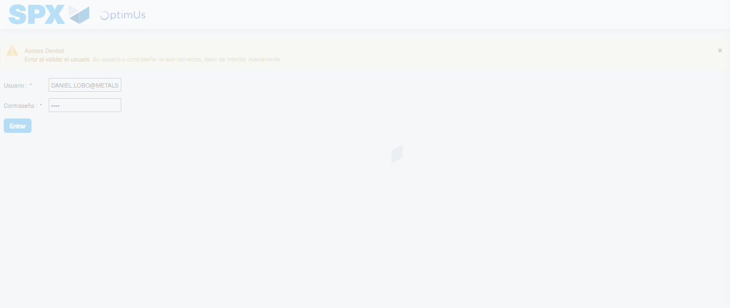Image file-name: QC_Testing-tc006_SPX_Dev5_Crear_Requisicion_Spot_Tipo_Cobro_Proyect_Urgent-1784215289447

Step 2 - Select to UEN and Access to Spot Buy Requisitions : UEN Correctly selected and Correct access
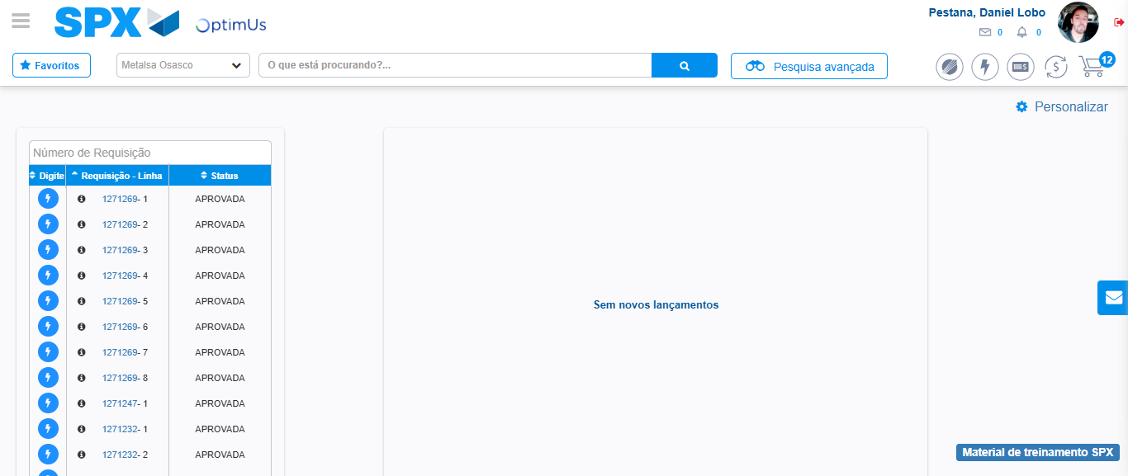Image file-name: QC_Testing-tc006_SPX_Dev5_Crear_Requisicion_Spot_Tipo_Cobro_Proyect_Urgent-1784215355704

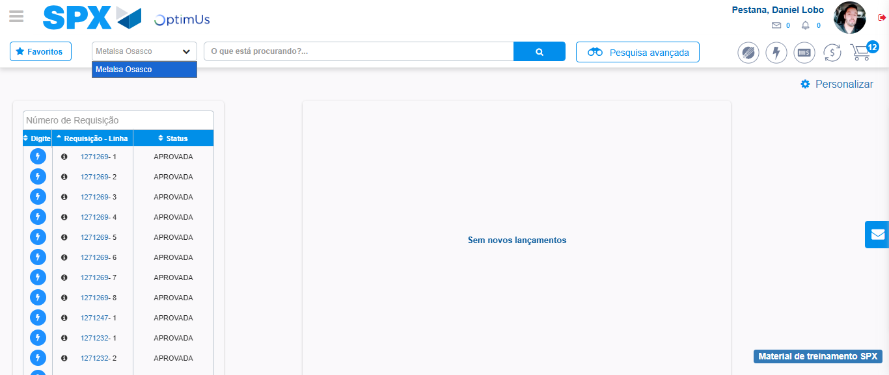Image file-name: QC_Testing-tc006_SPX_Dev5_Crear_Requisicion_Spot_Tipo_Cobro_Proyect_Urgent-1784215358188

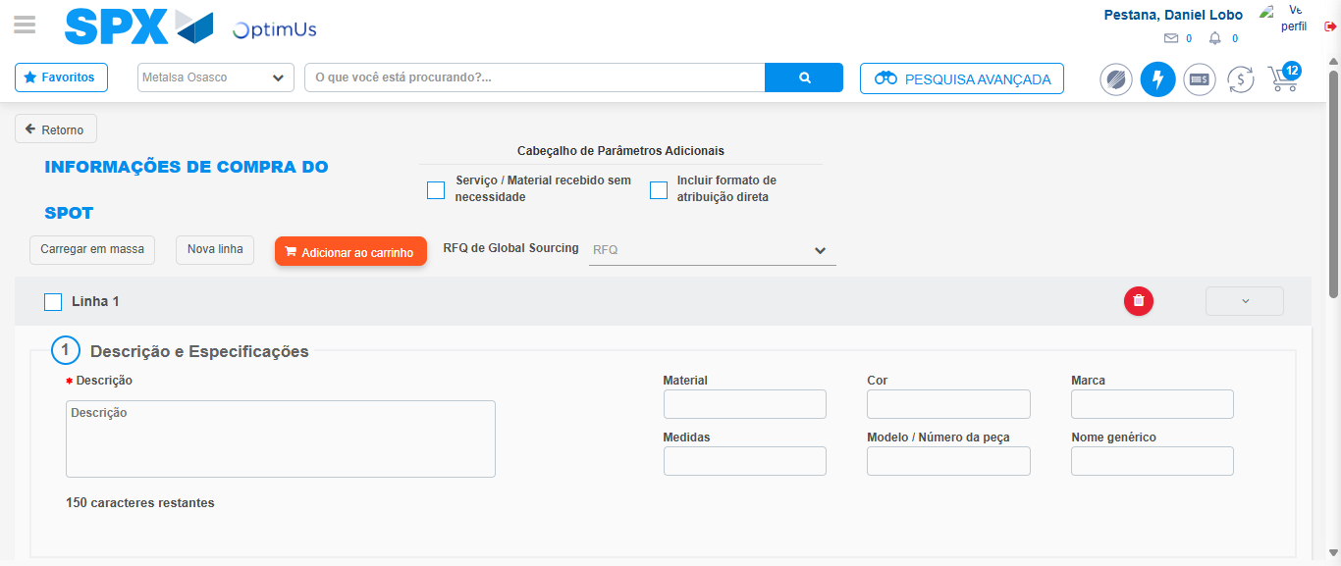Image file-name: QC_Testing-tc006_SPX_Dev5_Crear_Requisicion_Spot_Tipo_Cobro_Proyect_Urgent-1784215365897

Step 3 - Data Capture Spot Buy Requisition: Data captured correctly
Image file-name: QC_Testing-tc006_SPX_Dev5_Crear_Requisicion_Spot_Tipo_Cobro_Proyect_Urgent-1784215366164

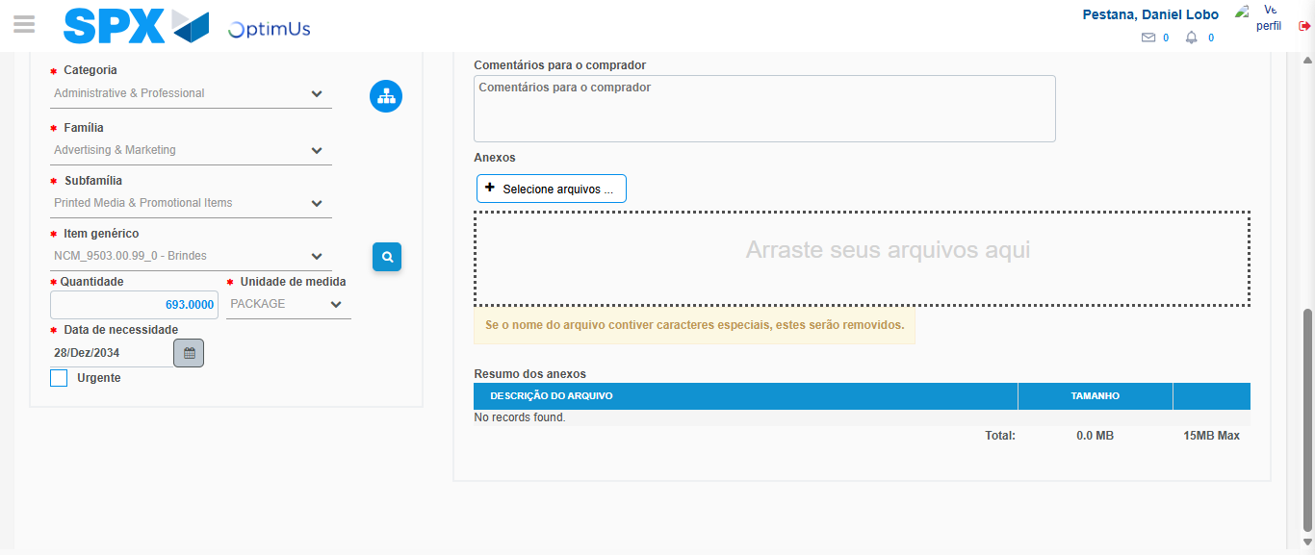Image file-name: QC_Testing-tc006_SPX_Dev5_Crear_Requisicion_Spot_Tipo_Cobro_Proyect_Urgent-1784215379584

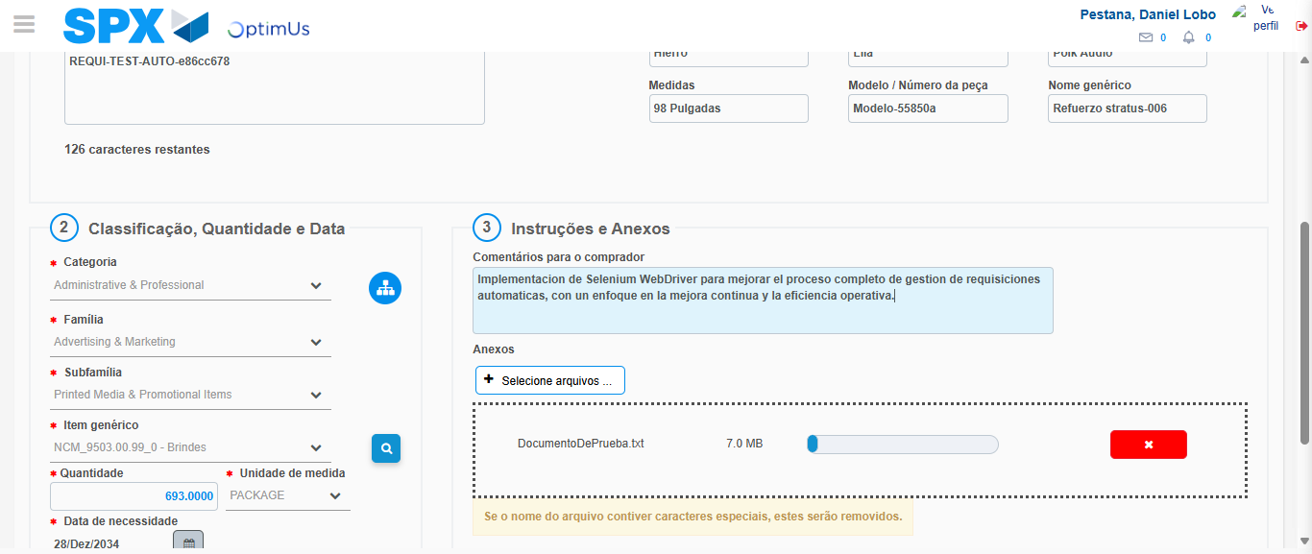Image file-name: QC_Testing-tc006_SPX_Dev5_Crear_Requisicion_Spot_Tipo_Cobro_Proyect_Urgent-1784215380609

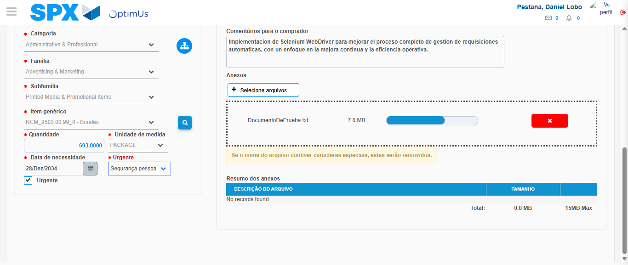Image file-name: QC_Testing-tc006_SPX_Dev5_Crear_Requisicion_Spot_Tipo_Cobro_Proyect_Urgent-1784215384523

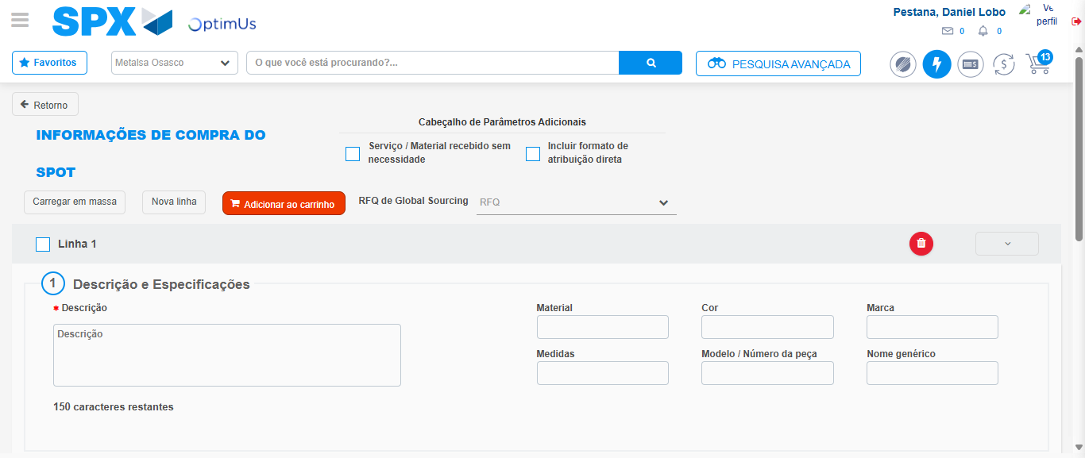Image file-name: QC_Testing-tc006_SPX_Dev5_Crear_Requisicion_Spot_Tipo_Cobro_Proyect_Urgent-1784215389737

Step 7 - Return to Main Page SPX : Return to Main Page SPX
Image file-name: QC_Testing-tc006_SPX_Dev5_Crear_Requisicion_Spot_Tipo_Cobro_Proyect_Urgent-1784215355704

Image file-name: QC_Testing-tc006_SPX_Dev5_Crear_Requisicion_Spot_Tipo_Cobro_Proyect_Urgent-1784215358188

Image file-name: QC_Testing-tc006_SPX_Dev5_Crear_Requisicion_Spot_Tipo_Cobro_Proyect_Urgent-1784215365897

Image file-name: QC_Testing-tc006_SPX_Dev5_Crear_Requisicion_Spot_Tipo_Cobro_Proyect_Urgent-1784215392047

Image file-name: QC_Testing-tc006_SPX_Dev5_Crear_Requisicion_Spot_Tipo_Cobro_Proyect_Urgent-1784215392246

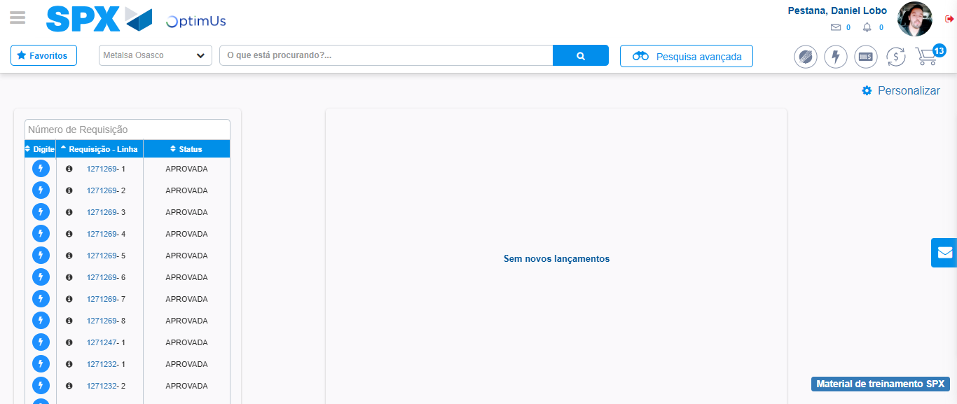Image file-name: QC_Testing-tc006_SPX_Dev5_Crear_Requisicion_Spot_Tipo_Cobro_Proyect_Urgent-1784215413400

Step 8 - Log Out : Log Out SPX
Image file-name: QC_Testing-tc006_SPX_Dev5_Crear_Requisicion_Spot_Tipo_Cobro_Proyect_Urgent-1784215413628

